# TWM – TracePQM Wattmeter

V1.1.0.0, 2018-03-16

TWM is open source project that is being developed for transparent traceable measurement of electric power and power quality parameters. It is being developed in scope of EMPIR project TracePQM [1].

It consists of two parts: (i) LabVIEW control module and GUI and (ii) Octave/Matlab calculation module. Control module (i) handles the HW, i.e. records the waveforms, selects correction files and initiates calculation of the parameters using control module. Calculation module (ii) is based in the QWTB toolbox [2] and it runs in either Matlab or GNU Octave. Both parts are integrated together.

## File formats

For documentation of the file formats generated by the TWM, see attached files in project ‘doc’ folder in the TWM main folder. The documentation of the correction file formats is/will be also present in the ‘doc’ folder. In current development version the best way to create custom corrections is to edit the examples in the folder ‘data/corrections/*’. Detailed reference manual for the corrections is in progress.

## Supported HW

TWM currently integrates drivers for control of:

1. PXI 5922 digitizer using National Instrument’s niScope and niTClk drivers (must be installed on the computer);
2. Sampling multimeters 3458A (NI’s VISA drivers must be installed);
3. DirectSound Drivers for handling soundcard as an ADC [3];
4. Simulated ADC which can generate composite harmonics signal. Note the DirectSound drivers (iii) are implemented only for demonstration purposes so the TWM can be run even without any external HW. It may be usable for low accuracy measurements, however it is not official part of the TracePQM project.

## GNU Octave/Matlab interface

Goal of the project TracePQM is to implement interface between TWM and Matlab/GNU Octave so the calculations can run transparently in the M-functions. In the current version both GNU Octave and Matlab are supported via interface GOLPI library [4]. Current version of the interface was tested with GNU Octave 4.0.0 and later however it should be possible to run it at least from version 3.6.4. It now works also with Matlab at least from version 2008b.

## Installation

TWM requires no installation. The TWM build folder can be copied to any disk location.

## Brief TWM documentation

The TWM is still in the development and all its functionality is subject to change. At the end of the project, the TWM will be documented with all the details. Following text describes only very basic usage of the current version.

Main panel of the TWM is shown in the Fig. 1. It contains several configuration buttons for configuration of the TWM components which will be described later. The button **VIEW RECORD** can be used to view the last recorded waveform(s). The button **STOP** is ungrayed whenever the TWM is busy and can be used to terminated the pending operation(s). Note it may take some time to respond on the STOP signal. Button **HW Corrections** will invoke panel for selecting the correction files.

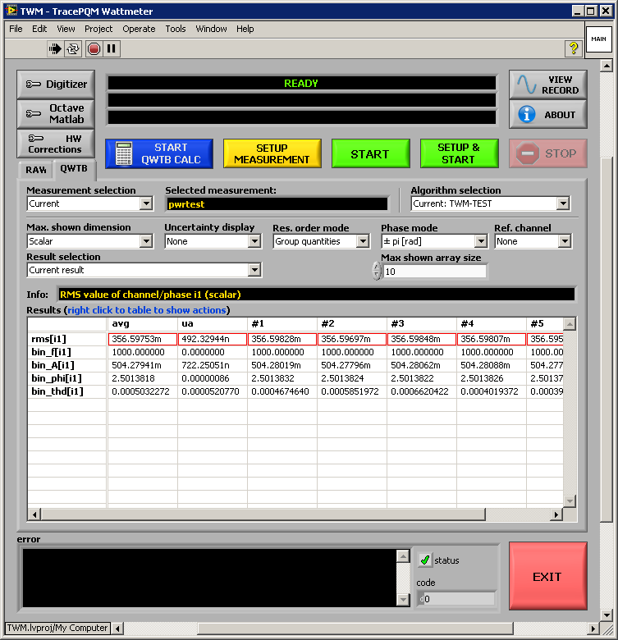

Fig. 1 - TWM's main panel

### Setup of the digitizing HW

First, the digitizer HW must be configured. The button **Digitizer** must be pressed in order to invoke Digitizer configuration panel. Example of the panels for niScope and 3458A digitizers are shown in the Fig. 2 and Fig. 3. The panel contains digitizer type selector which is used to select the HW to be used for the digitizing. Next, the virtual channels list must be filled in. The drives of 5922 (niScope) and 3458A are designed so the user can enter any count of channels. For 3458A, user must also select synchronization mode and sampling mode of the multimeters. Information panel on the left shows description of the selected mode. If the selected mode requires additional HW such as arbitrary waveform generator (AWG) or a counter the corresponding entries will be ungrayed and must be filled. Note both 5922 and 3458A have option **Use streaming** **mode** which is the mode in which the sample data are streamed directly to the file and the internal memory of the digitizer is not used. This mode will extend the maximum number of samples to record. Each digitizer has **TEST** function available. The **TEST** button will initialize the HW and detect eventual errors which will be shown in the black box. If the test is successful, the black box will contain identifiers of the HW components. If the digitizer support self-calibration procedure, the button **SELF-CAL** will be ungrayed. Note the instruments may have option to lock its reference frequency to external 10 MHz (or another) source.

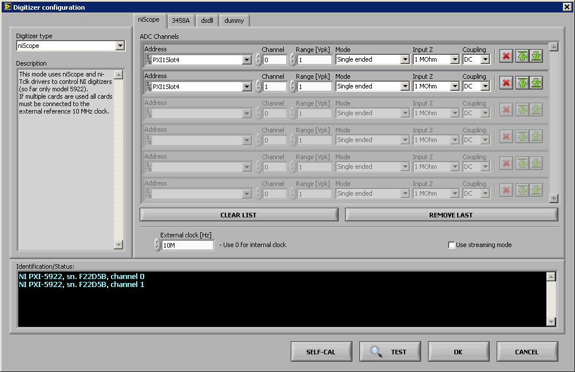

Fig. 2 - niScope configuration panel.

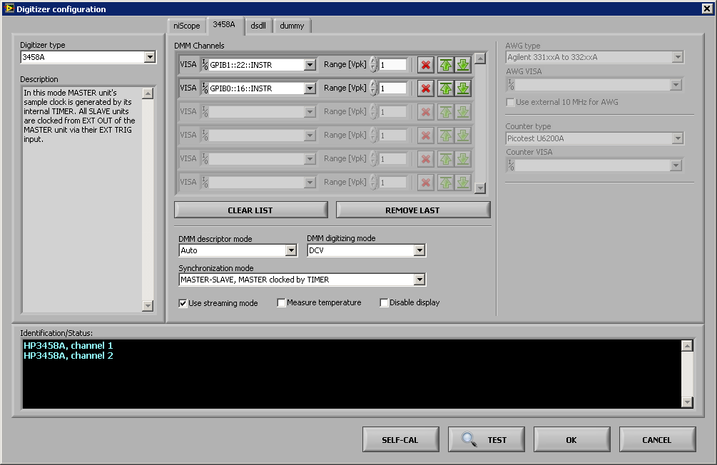

Fig. 3 - 3458A multimeters configuration panel.

### Setup of the corrections

Next step is configuration of the corrections which is invoked by pressing button **HW Corrections**. Panel shown in Fig. 4 will be displayed. The panel has two tabs. First is **Transducers**. In this panel user can load correction files for each voltage/current transducer. Each transducer has **Phase index**, which defined to which phase it is attached. Typically this is used for power measurement in multiple phases. Note for calculation of power each phase must have one voltage and one current transducer. Next, user must attach the transducer to channels of the digitizer by drop menus **ADC High** and **ADC Low**. For single ended connection of the transducer, the ADC Low will be set to ‘Not used’. For differentially connected transducer the low-side channel of the digitizer must be selected.

If no corrections are required, the dummy transducers with unity gain can be loaded or the list can be cleared. However, clearing the list means TWM cannot recognize which transducers are voltage and current. Example corrections are stored in folder ‘data/corrections/transducers’.

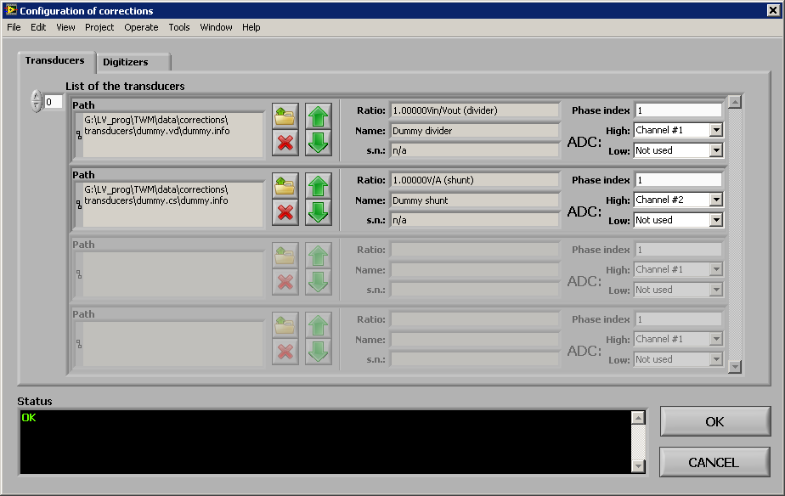

Fig. 4 – Correction of the transducers.

Next tab is **Digitizers** (shown in Fig. 5). This is used to select correction files for the digitizer setup and its channels. In this panel user can load correction session for the digitizer setup, i.e. for the group of instruments. When the file is loaded, the expected identifiers of the components will be shown in **Correction identifier** windows. These must match the identifiers read from the actual digitizing HW. The test is performed by pressing **CHECK HW CONSITENCY**. The actual identifiers will be shown and status indicator will show result. The corrections can be cleared by pressing **CLEAR CORRECTIONS**. Example corrections are stored in the TWM’s folder ‘data/corrections/digitizer’. Note the count of digitizer channels in the correction files must match the detected count of channels.

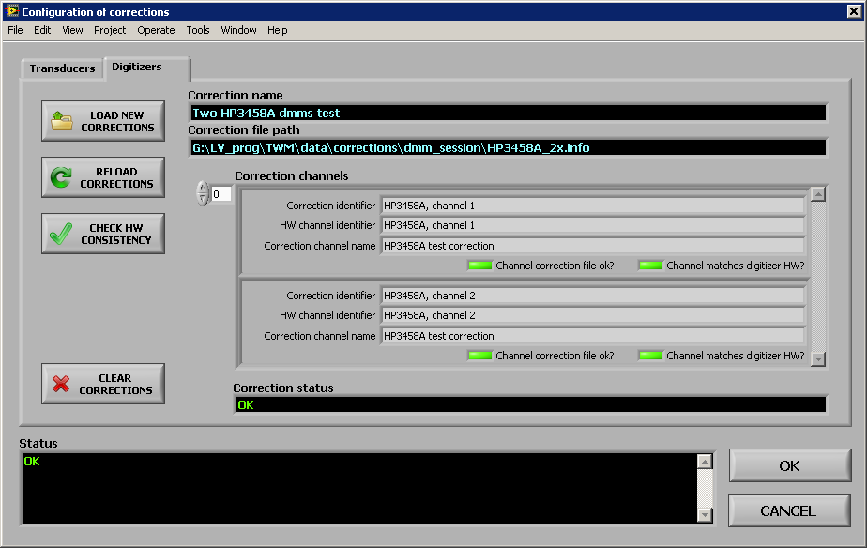

Fig. 5 – Corrections of the digitizers.

### Date processing environment setup

If user wants to process the digitized data automatically after each measurement, the GNU Octave/Matlab interface must be configured using button **Octave/Matlab** on the main panel of TWM. The panel shown in the Fig. 6 will be displayed. In this panel, user must either enter path to the binary folder of the GNU Octave installation or select Matlab mode. By pressing **Restart**, the Octave/Matlab will be started. If successful the detected version will be displayed.

The window contains several options:

‘**Enable Matlab Script mode**’ – Will execute commands via Matlab instead of GNU Octave.

‘**Always clear function cache’** – This is for debugging purposes. It will reload all m-functions before each command. Without this the TWM won’t recognize changes made in the m-files. Disable to speedup operation.

‘**Use bitstream mode**’ – This is supported only for GNU Octave and it means the data between Octave and LV will be transferred in binary (faster way). The TWM should offer auto installation of the needed package.

‘**Show console window**’ – This is valid only for GNU Octave. It will show debug console where one can inspect traffic between Octave and LV. Note it is read-only console and it may slow down operation of TWM. Do not close the console window! It will cause hard crash.

When calculation via QWTB toolbox is required, the user must set the path to the QWTB toolbox. The setup of the QWTB is verified by pressing **TEST QWTB**. Note the current version of TWM has a local copy of the QWTB with few algorithms placed in the folder ‘octprog’ of the installation so use this by default. Note this is just for development purposes and will be removed in final versions.

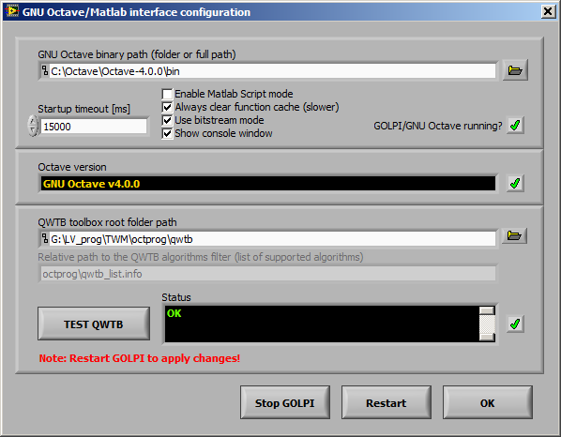

Fig. 6 - Octave/Matlab configuration panel.

### New measurement setup

When the basic configurations are done, the new measurement may be configured by pressing **SETUP MEASUREMENT** or **SETUP & START**. This will initiate panel show in the Fig. 7. Here, user must setup sampling parameters such as samples count, sampling rate, triggers, etc. User must also setup destination folder for the measured data. User may also use variables in the file name which will be replaced by the automatic text. The actual destination folder with the replacements is always shown. E.g.: name ‘my_measurement_no_%id%’ will be replaced by the **Measurement number** to ‘my_measurement_no_68’.

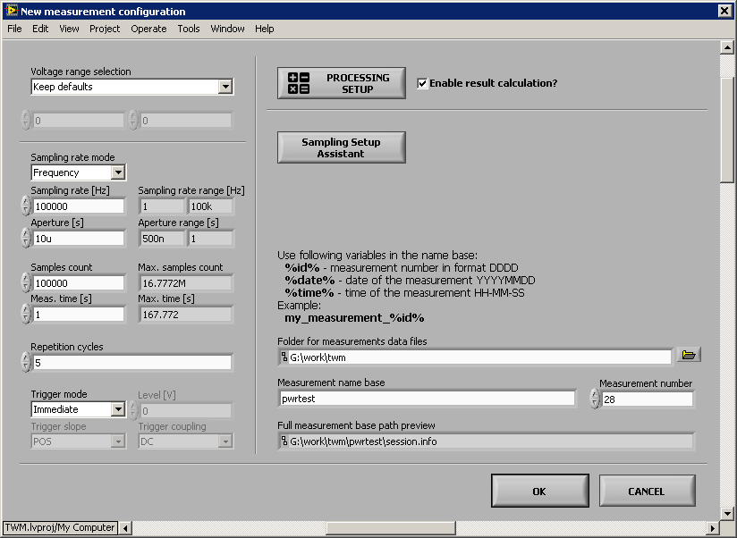

Fig. 7 - New measurement configuration.

The panel contains option **Sampling Setup Assistant**. This button will initiate panel shown in Fig. 8. This is a simple panel for calculating coherent sampling setup for given frequency. The **FIND ROUGH** will not look for coherent setup. It will only calculate approximate sampling setup. The button **FIND COHERENT** will call m-script that tries to find the setup for selected HW. User can select allowed range of sampling rates and sampling times and tolerance. Note this requires GNU Octave or Matlab. The reference frequency can be entered manually or measured using the tool invoked by button **MEASURE**. Note the whole search tool is very experimental and not always it works. There still some troubles with rounding errors, so sometimes it is necessary to enter sampling rate of 49.999k instead of 50k to set 50k.

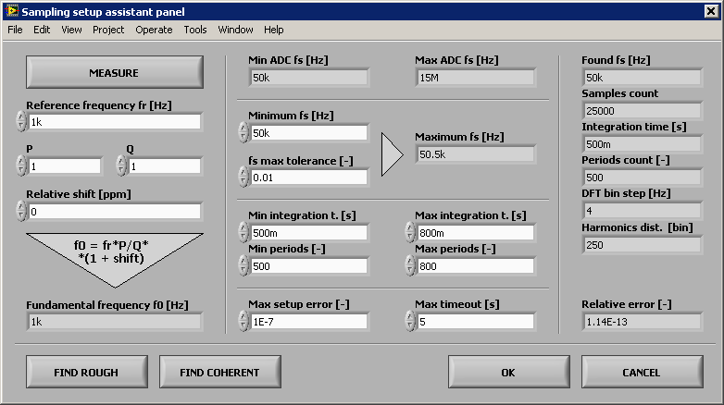

Fig. 8 – Sampling setup assistant.

#### Data processing setup

If the calculation should be performed automatically on the recorded data, the user must also configure the processing using by pressing **PROCESSING SETUP** and the checkbox **Enable result calculation?** must be checked. The button **PROCESSING SETUP** will invoke panel show in the Fig. 9 or Fig. 10. By selecting the page **RAW command** a raw command mode is selected. In this mode, the TWM will execute the Octave/Matlab code placed in the text box as it is. Several ways of displaying the results are available. Note it is possible to plot graphs from this section. In example you can see how the measured data can be loaded (function **tpq_load_record**).

If **QWTB** page is selected, the TWM will execute the QWTB algorithm on the recorded data. In the QWTB mode, the **List of algorithms** will be filled by the available algorithms if the Octave/Matlab interface and path to the QWTB is configured. When the algorithm is selected, its information from QWTB toolbox will be displayed on the right and the flags showing its capabilities will be shown. If the algorithm has user definable parameters, such as the one shown in the example in the Fig. 10, the list of the parameters will be shown in the table. User may fill the values. Each algorithm may have uncertainty calculation option, which may be selected if required but in current version this option must be set to ‘none’. Some algorithms such as TWM-THDWFFT supports calculation from multiple records at once. This is enabled by the checkbox **Calculate result just once when all records are measured?**. Note only the algorithms listed in the file ‘octprog/qwtb_list.info’ in the TWM’s folder will be loaded in the list. This file defines behavior of the algorithms and display mode of the results. Details are in the comments in the file itself. In general the TWM will work with algorithms starting with ‘TWM-‘ prefix. Others are not tested.

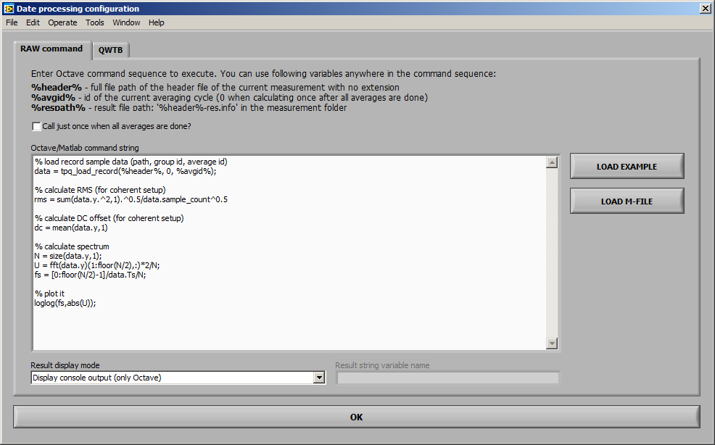

Fig. 9 - Configuration of the calculation (RAW commands mode).

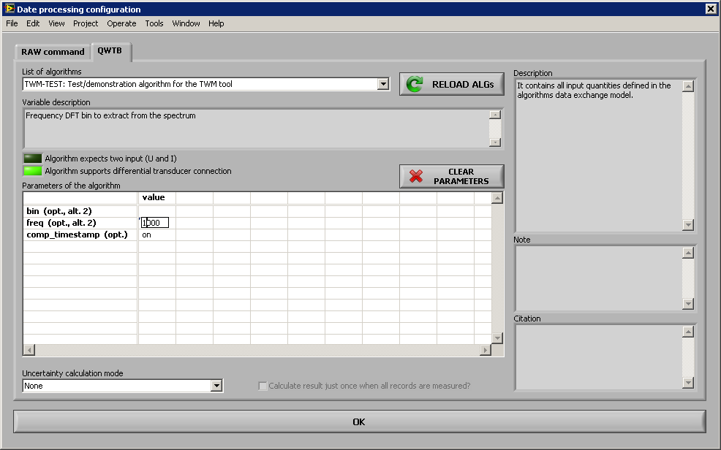

Fig. 10 - Configuration of the calculation (QWTB toolbox mode).

### Measurement initiation

When the configuration of the measurement is done, user may initiate it by pressing **START** on the main panel (or in the measurement configuration panel). The TWM should start the measurement sequence as defined in the measurement setup. The process can be terminated at any time by pressing **STOP**.

### Results viewing

When the record is done and eventual calculation it performed, the results are available on the main panel. In the **RAW command** mode, the result is plain text. In the **QWTB** node, the result is formatted table. User has several options, such as order of the quantities, selecting the uncertainty display mode, etc. User may select to display results of the current measurement and current algorithm. But it is also possible to select older measurement by the **Measurement selection** menu. Eventually, the display may be disabled which may be helpful when large data are to be shown. The TWM always reloads all the result files, so it may take some time to update the view. Right click to the table will show options, such as graph display or data exporting.

### QWTB post-processing

Each measured dataset can be processed or reprocessed later manually to obtain new parameters by different algorithms. This is invoked by pressing **START QWTB CALC** button which will show panel Fig. 11. In this panel user must select measurement session. This will show list of measurement groups and particular records. Next, a QWTB processing panel can be invoked by **PROCESSING SETUP**. By pressing **START** the processing of the whole batch will start. All calculated algorithms will appear in the main panel in the dropdown menu **Algorithm selection**.

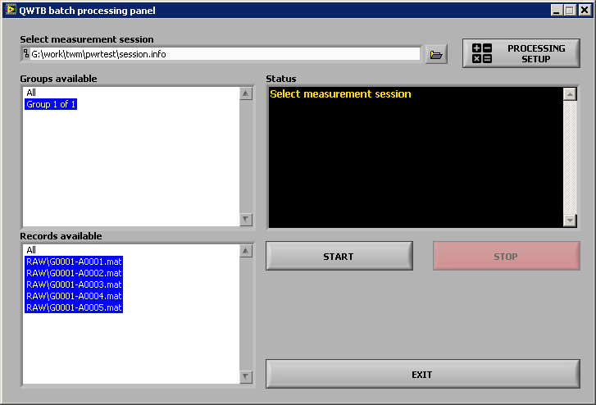

Fig. 11 - Configuration of the manual QWTB calculation.

## References:

[1] EMPIR project TracePQM,   
www: <http://tracepqm.cmi.cz/>

[2] QWTB Toolbox,   
www: <https://qwtb.github.io/qwtb/>

[3] DirectSound DSDLL library,  
www: <http://www.elektronika.kvalitne.cz/SW/dsdll/dsdll_eng.html>

[4] GOLPI library – Gnu Octave to LabVIEW Pipe Interface,  
www: <https://github.com/KaeroDot/GOLPI>